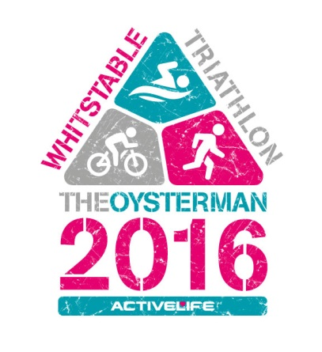

Volunteer

Hello and thank you for helping to support the 2nd Active Life Oysterman Triathlon, this is set to be a fantastic event and will hopefully be an event that will return year after year which, alongside other great sporting events being held in the area, will promote the sport of triathlon, healthy living and a more active lifestyle.
We will also be supporting local charities.

However this event can only happen with the help of you and a small army of volunteers to help with safety, marshalling, water stations and many other aspects of the triathlon.

If you are interested in volunteering please fill out the details section below and send it back to me either by email or post to-

Richard Oliver
36 Old Bridge Road,
Whitstable
Kent,
CT5 1RQ
Email- oysterman-tri@hotmail.com

Name:

D.O.B:

Contact Number:

Email:

Additional info: (previously marshalled for events, special skills e.g kayaker, road traffic management, organiser, first aider etc.) or just something interesting about yourself!

Thank you so much again and I look forward to hearing from you
Richard Oliver Event organiser

